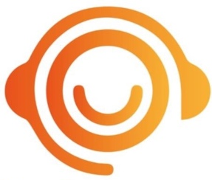
Stardust Events
How a Race Night Works
A race night is a fantastic straightforward fun way to raise funds for your organisation.
There are several jobs that will need to be done before and during the race night, ultimately the amount of effort that goes in determines how much money you will raise.
Before your race night
Events Organiser – Someone to put up race night posters (supplied with our pack), speak with local companies and suppliers to get prizes and sponsorship for the race night, and sell advanced race night entry tickets.
During the race night
A Race Night Master of Ceremonies – We supply a Race Host that will run the race night on the night for you, as well as sell your tote tickets and supply all equipment needed to make your race night run at a profit.
Race Night
Tote Ticket Sellers & Payout – You can have your own sellers or our race night host will be happy to sell the tote tickets for you. Please make sure you have a £100 float on the night.
As an organisation, you decide on the size of each race night bet. This can be anything you like but we recommend either 50p or £1.00 then keep to that price of bet. You then decide how much of the race night tote the charity will retain for their funds, normally 50% but can be any percentage you decide. You let everyone know before the first race what the cost of a bet is and what percentage is going to the funds.
YOUR RACE NIGHT IS RUN UNDER THE LOTTERY AND AMUSEMENT ACT 1976:
To comply with regulations, we suggest the following
- Open the betting for the first race, and take the bets.
- When all bets have been placed the race night tote is closed.
- Ask a member of the audience to choose a race film number at random from the DVD.
- Show the film on the television or screen.
- Before the race starts a fun form guide gives a brief rundown on each of the runners.
- As no more bets can be placed at this point, you have complied with the regulations.
We are looking forward to suppling you with one our famous race nights lets make it a great success. Upload you photos and advertise your event #stardusteventsne

